**Bootstrap Basic & Advanced**

* **What are the advantages of Bootstrap?**

The advantages of Bootstrap are as follow.

1. Responsive Design – Helps to create websites to look good.
2. Consistency – It maintains a uniform design across the project.
3. Customizable – It helps to fit the specific design needs.
4. Fast Development – It speeds up the development process to ready to use components.
5. Accessibility – It enhance the usability for people with disabilities.
6. Integration with JavaScript Plugins – That add interactive features to the site.

* **What is a Bootstrap Container, and how does it work?**

A Bootstrap container is a class used to wrap and contain the content of a webpage within a fixed width container and it helps to center and align the content horizontally as well as maintain consistent spacing and layout across different screen sizes.

Ex :-

**<div class= “container”></div>**

* **What are the default Bootstrap text settings?**

The default text settings in Bootstrap are as follow.

1. Font family.
2. Font size.
3. Font weight.
4. Line weight.
5. Text color.
6. Text alignment.
7. Text decoration.

* **What do you know about the Bootstrap Grid System?**

The Bootstrap Grid System is a flexible layout tool in the Bootstrap framework, dividing the webpage into 12 columns for responsive design.

* + **What is the difference between Bootstrap 4 and Bootstrap 5**

Bootstrap 5 introduced vanilla JavaScript, enhanced utility classes, dropped IE support, updated the grid system and improved documentation compared to Bootstrap 4.

* + **What is a Button Group, and what is the class for a basic Button Group?**

A Button Group is a component in Bootstrap that groups a series of button and allowing them to be visually connected and organized. This component is useful for presenting related actions or options in a cohesive manner. The class for a basic Button Group is **‘.btn-group’**.

* + **How can you use Bootstrap to make thumbnails?**

To create thumbnails using Bootstrap, you can use the ‘.img-thumbnail’ class along with the ‘img’ tag to apply styling.

Example :-

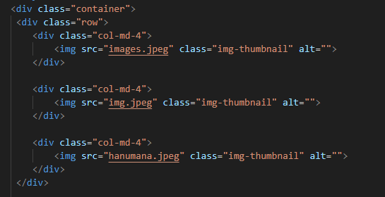

Output :-

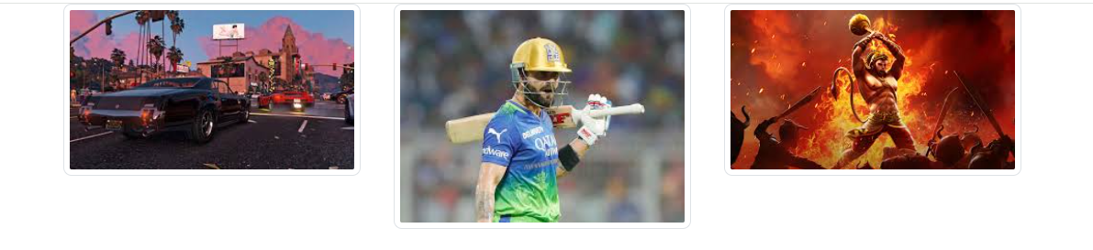

* + **In Bootstrap 4, what is flexbox?**

In Bootstrap 4, flexbox refers to the Flexible Box Layout module of CSS that is utilized for creating flexible and responsive layouts. It extensively utilizes flexbox for its grid system and various components. It also enables developers to easily align elements within a container and making it simple to create complex and responsive layouts without relying heavily positioning.

* + **How can one create an alert in Bootstrap?**

To create an alert in Bootstrap, use the ‘.alert’ class along with contextual classes like ‘.alert-primary’, ‘.alert-success’, ‘.alert-info’, ‘.alert-warning’.

* + **What is a bootstrap card and how would you create**

A Bootstrap card is flexible and extensible content container. It’s a versatile component used for displaying various types of content, such as images, text, links, buttons and more in a structured and visually appealing manner.

Example :-

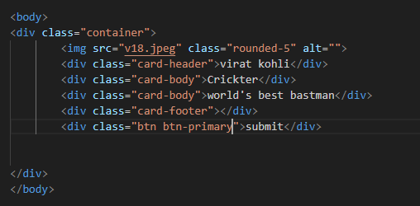

Output :-

